13.65: a) 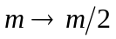
Splits at
k stays same
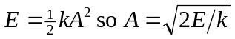
Then 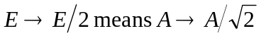

b)
Splits at 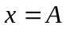 where all the energy is potential energy in the spring, so  doesn’t
change.
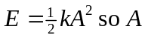stays the same.
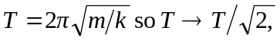as in part (a).
c) In example 13.5, the mass increased. This means that increases rather than decreases. When the mass is added at 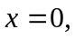the energy and amplitude change. When the mass is added at 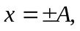the energy and amplitude remain the same. This is the same as in this problem.

